**Talal Al Otaibi**

**Fume Box**

Version 1.0

*This project is dedicated to all those who have died to due to asphyxiation due to*

*hazardous gases brought about by unsafe gas heaters and stoves…*

**1.0 Overview**

Amman - Despite the awareness guidelines issued by the Directorate of Civil Defense and the messages published by the media that contribute to raising awareness among citizens about how to properly use heaters, the deaths from suffocation continue to reap the lives of many. According to the Department of Public Information, statistics by the Civil Defense Directorate in

2009 show that more than 394 incidents, resulted in 332 injuries and 9 deaths due to gases

produced due to the misuse of unsafe heaters in winter. The latest story involves the suffocation of six-members family in the northern part of the northern desert, where they were sadly died by a gas stove that had been burning all night.

This resulted in the death of the parents and their four children aged between one and seven years, while two boys sleeping in another room of the same house survived the choking incident.

What triggered me to initiate the project is the death of an old man at the Zaatari camp during my visit in fall. The man died in his sleep while the gas heater was on. All this occurred during my visit to the camp.

Therefore; I came up with the idea of the **Fume Box** project as heaters are essential in every home that lacks a central heating system, but at the same time it can pose a great threat to human life if not handled with care and attention and with a degree of responsibility.

**2.0 Objectives**

The “FumeBox” project objectives are:

Help the user to monitor any lethal gases present.

Warn the user of imminent danger brought by asphyxiating gases.

Assist the Civil Defense Directorate in their initiative to reduce death by choking.

To ensure the efficacy of the project, the project cost must be minimized to ration in as many low-income consumers as possible, especially as lower-income households tend to be more reliant on the presence of gas heaters due to the lack of costly central heating and proper insulation.

Therefore, minimized costs, easy user interface, compactness, and overall device reliability and responsiveness are crucial specifications to be met.

Basic specs:

Size must not exceed 10x10x10 cm, height, width, and length.

Mass must not exceed that of 1kg, otherwise it is to bulky to move around by hand, despite its use as a stationary smoke detector.

Costs must not exceed JOD 20, around $28.

Notifications and the buzzer must go off (response time) within 10 seconds once gas/

smoke is emitted.

**3.0 Working Mechanism**

We can divide the working mechanism of the “FumeBox” project into main parts; Technical Part

and Programing Part and hereunder detailed information related to each section.

**3.1 Components**

The technical part of the project includes all the detailed information about the hardware equipment in the project.

**3.1.1 NodeMCU**

NodeMCU is an open source IoT platform. It includes firmware which runs on the ESP8266 Wi-Fi SoC from Espressif Systems, and hardware which is based on the ESP-12 module. The term "NodeMCU" by default refers to the firmware rather than the dev kits.

Figure 1

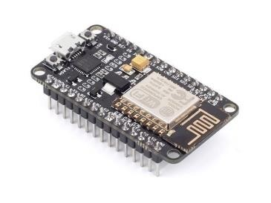

NodeMCU Features:

Open-source

Interactive

Programmable

Low cost

Simple

Smart

Wi-Fi Enabled

As the NodeMCU is programmable and open source IoT platform which can be connected to the internet; it was used to connect the hardware part with the internet; it sends the notification in case the percentage of harmful gases succeeds the normal percentage.

**3.1.2 Gas Sensor**

A gas detector is a device that detects the presence of gases in an area, often as part of a safety system. This type of equipment is used to detect a gas leak or other emissions and can interface with a control system so a process can be automatically shut down. A gas detector can sound

an alarm to operators in the area where the leak is occurring, giving them the opportunity to leave. This type of device is important because there are many gases that can be harmful to organic life, such as humans or animals.

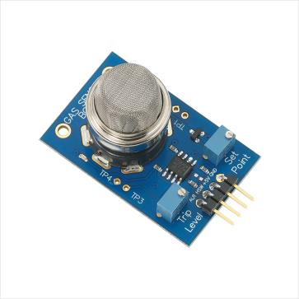

Figure 2

The use of the gas sensor in the project to detect the gas percentage and give an alarm in case the percentage of harmful gases succeeds the normal percentage.

**3.1.3 The Circuit**

The gas sensor is connected directly to the NodeMCU board as explained in the below figure 3:

Figure 3

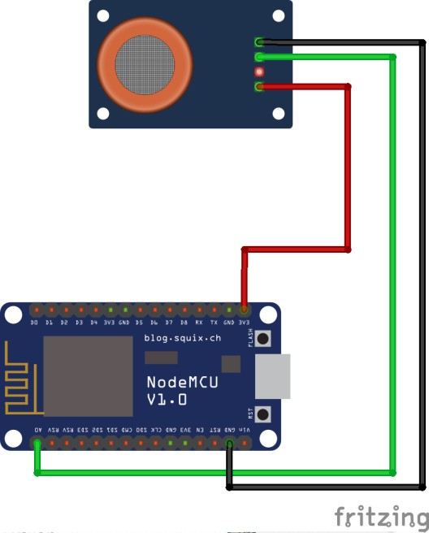

1) GND to GND (**Black Line**)

2) Vcc to 3v (**Red Line**)

3) Analog Output to A0 (**Green Line**)

**3.1.4 Switch**

An electrical switch is a device used to interrupt the flow of electrons in a circuit. Switches are

essentially binary devices: they are either completely on (“closed”) or completely off (“open”).

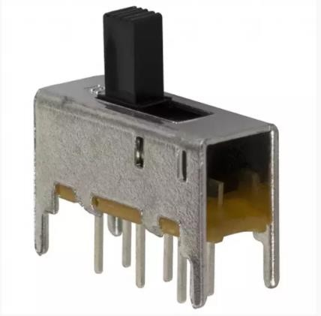

Figure 4

The used switch in the circuit is uxcell brand model a12013100ux0116 and is used to turn on and turn off the circuit.

**3.1.5 Wires**

Female – female wires such as the wires in figure 3 were used to connect the equipment and connect the circuit.

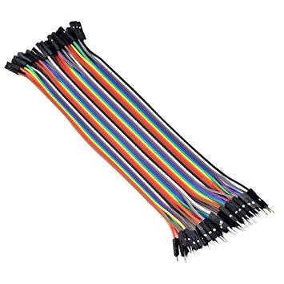

**3.1.6 Battery Holder**

Figure 5

The battery is the power source and it is used to deliver energy to the circuit and the battery holder is one or more compartments or chambers for holding a battery. For dry cells, the holder must also make electrical contact with the battery terminals. For wet cells, cables are often connected to the battery terminals, as is found in automobiles or emergency lighting equipment.

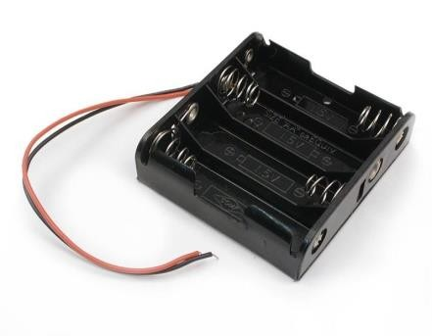

Figure 6

The battery used in the project to deliver the power was dry cells,3 V, and it was connected to the circuit through the battery holder.

**3.2 Software**

This is the part which explains how the FumeBox will connect to the mobile application via internet

**3.2.1 Languages**

The main language was used for the programming was “Arduino C” and the programming code for the NodeMCU was written using the Integrated Development Environment of the Arduino (Arduino IDE).

Further; the Blynk Arduino library was used to connect the Blynk application with the

NodeMCU.

**3.2.2 Applications and Web Services**

Blynk application for both versions IOS and Android was used to connect the Blynk application with the NodeMCU in addition to Blynk platform.

Further, some web services were used such as; NOdeMCU board, MQ2- Gas sensor and Buzzer. Furthermore; the Fritzing software was used to draw the final circuit and show the connections.

**3.2.3 Arduino Code**

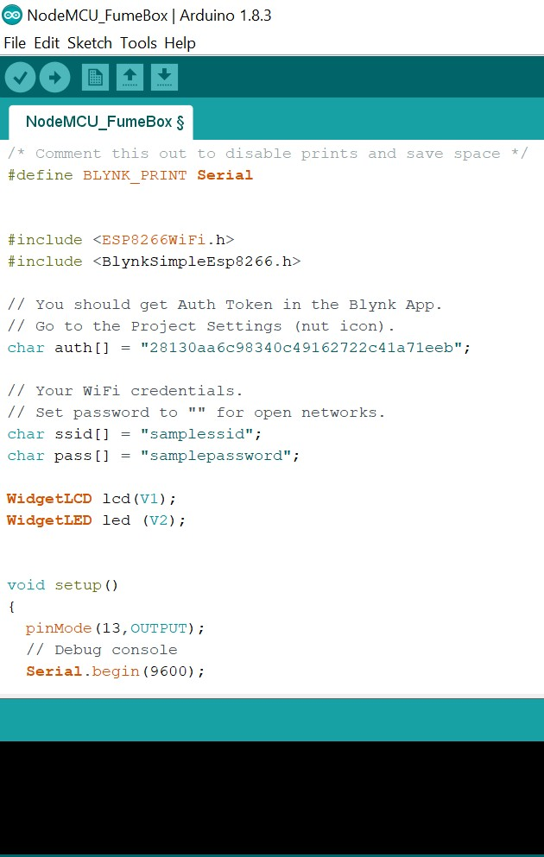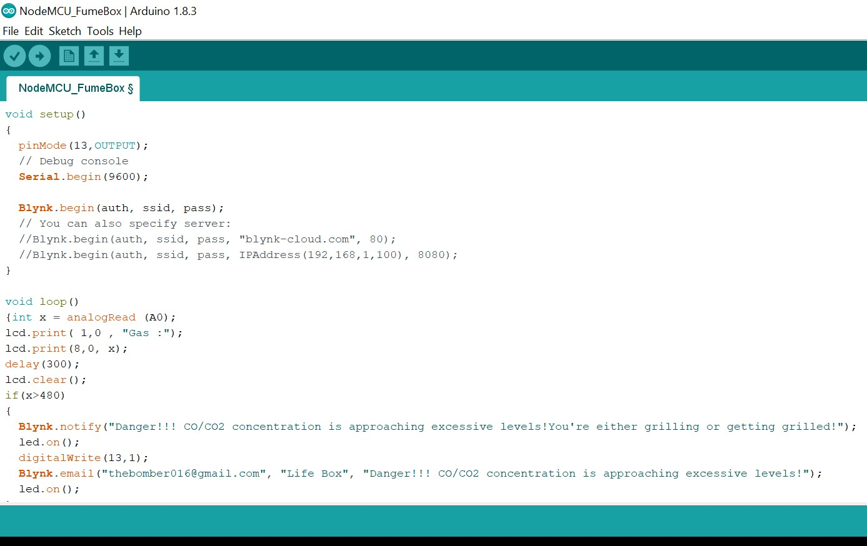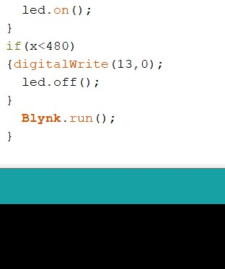

**Note that the buzzer has been assigned to an LED slot, as if it behaves**

**like an LED light with simple digital on and off.**

**5.0: Evaluation**

Strengths:

I translated the user interface to Arabic by changing the code, and the application user interface to Arabic. 10 people were given a brief explanation on what the product does and a layperson’s description on how it works.

- Out of these 10 people, 9 understood the presence of a lethal gas alert when the

alarm rang, and the notification was.

- This was tested using smoke emitted by burning a tissue (emission of carbon monoxide) due to incomplete combustion.

- Gas leak and emission of carbon monoxide using a gas heater.

Costs were minimized by purchasing a cheap plastic cover box, and simplifying the circuit setup. Aggregate expenditure on the components was JOD15, or around $21.14. The same 10 people, who ranged between low-income and a high-income found the product to be cheap and affordable.

The proper physical dimensions have been met: 6.5cm wide x 6.5cm long x 5cm high

(with sensor on top).

Average response time was 8.2 seconds. However, this is highly dependent on the distance of the FumeBox away from the smoke source.

Weaknesses:

It is too difficult to find the index at which smoke/ gas concentrations are lethal. Even if a certain concentration in moles was assumed, the lethal concentration differs due to biological differences such as mass and age. Gas diffuses from regions of higher concentrations to low, but the presence of windows and ventilation can easily render the device useless. Room volume, pressure, and temperature can also affect the rate at

which the gases defuse. As a result, there is no “perfect index” that can be selected, this

differs from home to home. This can easily render the device unreliable in the wrong situations

The device becomes far too unresponsive at distances above 5m

Learning Points:

Learnt NodeMCU programming

Improved skill in circuit assembly and wiring.

Became more apt at using IOT platforms.

**6.0 Future course of action**

It would be best to find a way to display the percentage of lethal present in a certain area, and entirely rework the unitless index system to improve the reliability and responsiveness of the system. The device meets most of the basic specifications, but this is considered a prototype that needs much more improvement.

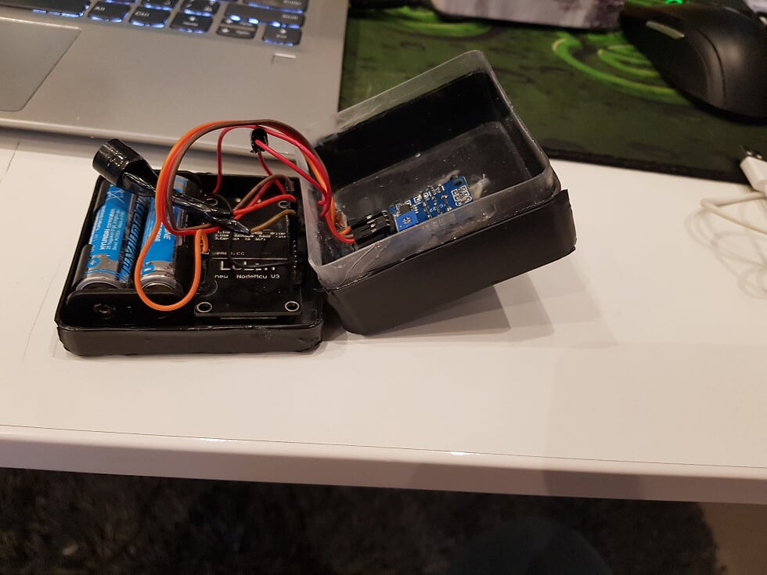**7.0 Evidence of Product**

